Window functions:

Introduction:
Windows functions are also called as analytical functions in some of RDBM’s.
Types of window functions:
  - ROW_NUMBER()
  - RANK()
  - DENSE_RANK()
  - FIRST_VALUE()
  - LAST_VALUE()
  - NTH_VALUE()
  - LEAD()
  - LAG()
  - CUME_DIST()
  - PERCENT()
  - NTILE()

Windows functions using aggregate functions:
Best way to start window functions is using aggregate functions in it. For example, I have below table where I want to find the maximum salary.
drop table employee;
create table employee
( emp_ID int
, emp_NAME varchar(50)
, DEPT_NAME varchar(50)
, SALARY int);

insert into employee values(101, 'Mohan', 'Admin', 4000);
insert into employee values(102, 'Rajkumar', 'HR', 3000);
insert into employee values(103, 'Akbar', 'IT', 4000);
insert into employee values(104, 'Dorvin', 'Finance', 6500);
insert into employee values(105, 'Rohit', 'HR', 3000);
insert into employee values(106, 'Rajesh', 'Finance', 5000);
insert into employee values(107, 'Preet', 'HR', 7000);
insert into employee values(108, 'Maryam', 'Admin', 4000);
insert into employee values(109, 'Sanjay', 'IT', 6500);
insert into employee values(110, 'Vasudha', 'IT', 7000);
insert into employee values(111, 'Melinda', 'IT', 8000);
insert into employee values(112, 'Komal', 'IT', 10000);
insert into employee values(113, 'Gautham', 'Admin', 2000);
insert into employee values(114, 'Manisha', 'HR', 3000);
insert into employee values(115, 'Chandni', 'IT', 4500);
insert into employee values(116, 'Satya', 'Finance', 6500);
insert into employee values(117, 'Adarsh', 'HR', 3500);
insert into employee values(118, 'Tejaswi', 'Finance', 5500);
insert into employee values(119, 'Cory', 'HR', 8000);
insert into employee values(120, 'Monica', 'Admin', 5000);
insert into employee values(121, 'Rosalin', 'IT', 6000);
insert into employee values(122, 'Ibrahim', 'IT', 8000);
insert into employee values(123, 'Vikram', 'IT', 8000);
insert into employee values(124, 'Dheeraj', 'IT', 11000);
COMMIT;

select * from employee;

Query to find max salary in given employee table.
select max(salary) from employee;
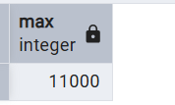

Good, now get each department wise max salary.
select dept_name,max(salary) as max_salary from employee
group by dept_name;
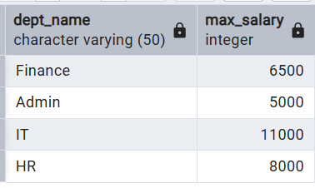

This is fine, but I want to keep existing data same and get max salary in each department. This we can achieve by writing complex quires like sub-query and join but by using windows we can do very easy.
select *,max(salary) over()
from employee
order by dept_name;
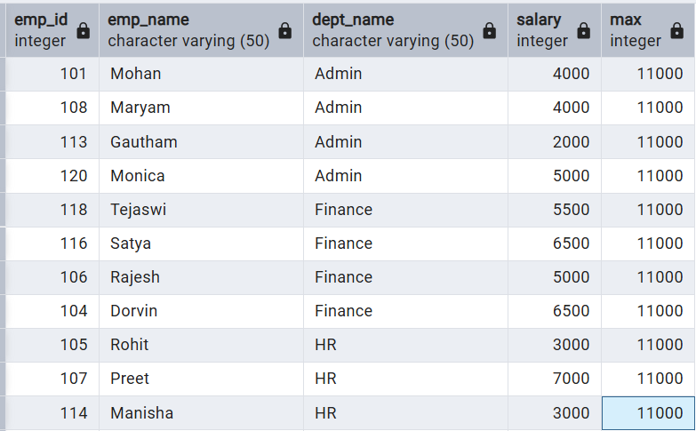

As, we have not mentioned anything inside over clause it will treat all table as one window and get max salary. In this case 11000 is max salary. But we need department wise so we can use partition by clause to tell SQL that use department for windows.
select *,max(salary) over(partition by dept_name)
from employee
order by dept_name;
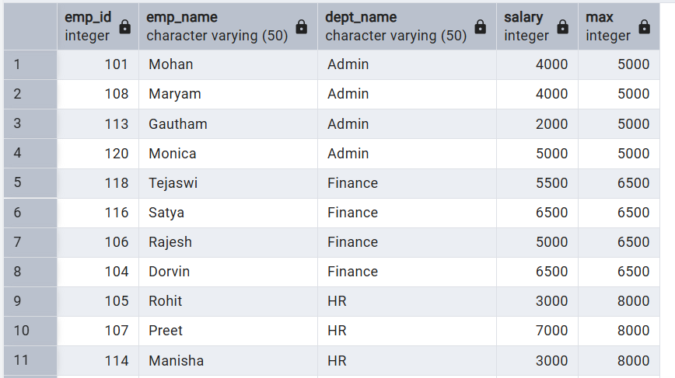

Note: Now you can see that max salary is reflecting for each department separately. Like that we can use other aggregate functions like min, count, sum and avg.

Row_number():
ROW_NUMBER () is a window function in SQL that assigns a unique sequential number to each row within a partition, based on an ORDER BY condition.
Below query uniquely give each number to record as we mentioned to SQL take total table as window.
select *,
row_number() over()
from employee;

Below query give unique number based on department. As we used partition by department.
select *,
row_number() over(partition by dept_name)
from employee;

Use case:
Suppose I want to find 2 employees who joined company early department wise. (Assume employee whose emp_id is less means that person joined early in company)
select *
from
(select *,
row_number() over(partition by dept_name order by emp_id) as row_num
from employee) as tbl
where tbl.row_num <3;

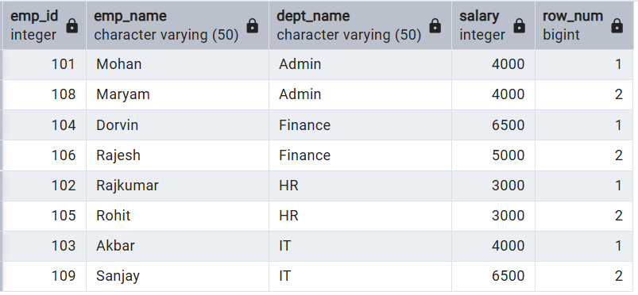

Rank:
RANK () assigns a rank to each row within a partition based on the ORDER BY clause. Ties get the same rank, and the next rank will skip numbers (because of the tie).
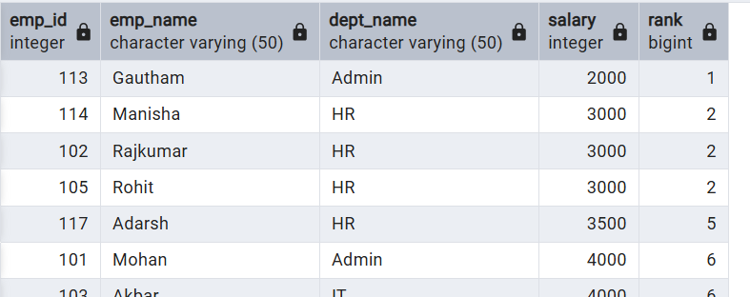
If we see above, 3 employes tied with 3000 salaries. Next employee given with 5th as rank.

Fetch the top 3 employees in each department earning the max salary.
select * from
(select *,
rank() over(partition by dept_name order by salary desc) as rnk
from employee) tbl
where tbl.rnk<4;
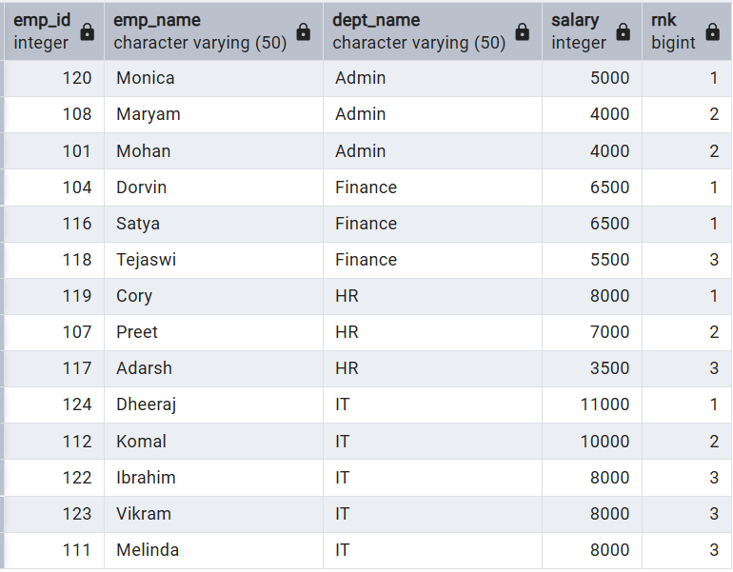

Dense_Rank:
Dense Rank is almost same as rank but only difference is dense rank never skip any value like how rank dose.
select *,
rank() over(partition by dept_name order by salary desc) as rnk,
dense_rank() over(partition by dept_name order by salary desc) as dense_rnk
from employee;
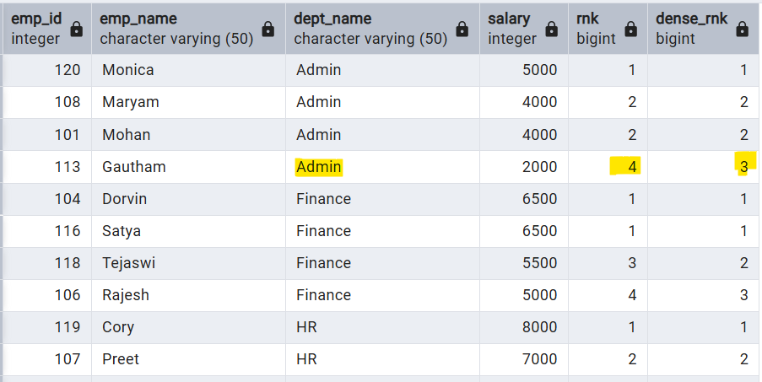

Note: Dense rank never skips that next value but rank dose.

Lead & Lag:
  - LAG() returns the previous row’s value (based on ordering) without using a self join.
  - LEAD() returns the next row’s value.
select *,
lag(salary) over(partition by dept_name order by emp_id) as perv_salary,
lead(salary) over(partition by dept_name order by emp_id) as next_salary
from employee;

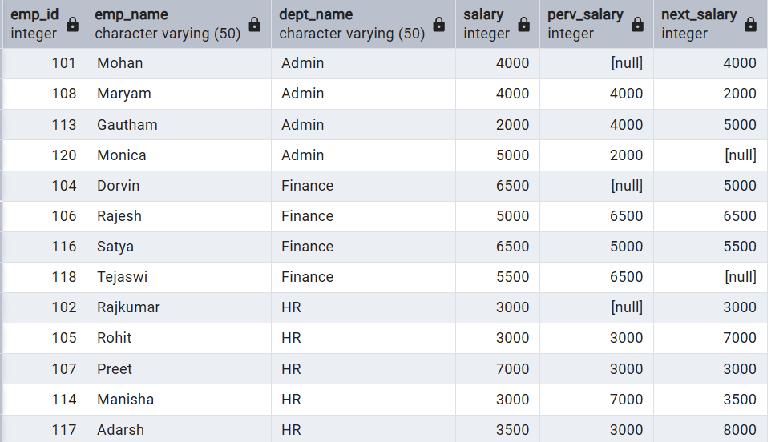

By default, here lag and lead will take 1 value previous or next and also if no value there it will fill with null. We can control then by-passing extra parameters like below.
select *,
lag(salary,2,0) over(partition by dept_name order by emp_id) as perv_salary,
lead(salary,2,0) over(partition by dept_name order by emp_id) as next_salary
from employee;
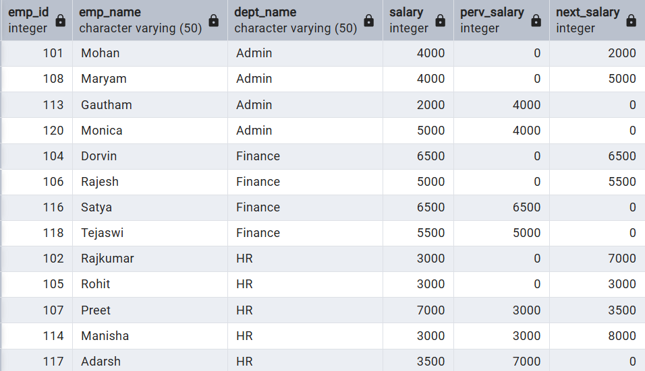

Use Case:
Fetch a query to display if the salary of an employee is higher, lower or equal to the previous employee.
select *,
CASE
WHEN salary > lag(salary) over(partition by dept_name order by emp_id) THEN 'Hihger'
WHEN salary < lag(salary) over(partition by dept_name order by emp_id) THEN 'Lower'
WHEN salary = lag(salary) over(partition by dept_name order by emp_id) THEN 'Equal'
ELSE 'NA'
END "Status"
from employee;
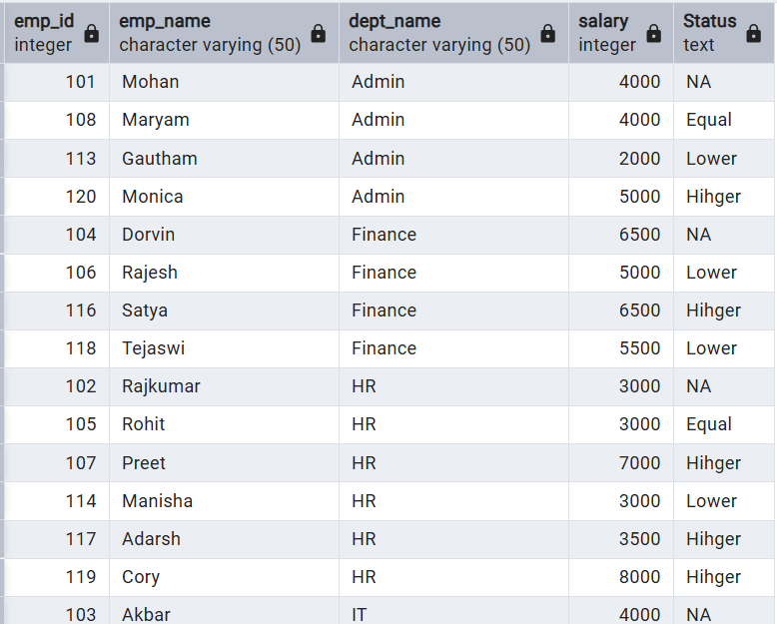

First value, Last value and Nth value:
FIRST_VALUE() is a window function in MySQL that returns the first value from an ordered set of rows within a window (partition).
DROP TABLE if exists product;
CREATE TABLE product
(
product_category varchar(255),
brand varchar(255),
product_name varchar(255),
price int
);

INSERT INTO product VALUES
('Phone', 'Apple', 'iPhone 16 Pro Max', 1300),
('Phone', 'Apple', 'iPhone 16 Pro', 1100),
('Phone', 'Apple', 'iPhone 16', 1000),
('Phone', 'Samsung', 'Galaxy Z Fold 6', 1800),
('Phone', 'Samsung', 'Galaxy Z Flip 6', 1000),
('Phone', 'Samsung', 'Galaxy S24 Ultra', 1200),
('Phone', 'Samsung', 'Galaxy S24', 1000),
('Phone', 'Nothing', 'Nothing Phone 2a', 300),
('Phone', 'Google', 'Pixel 9 Pro', 900),
('Phone', 'Google', 'Pixel 9', 600),
('Laptop', 'Apple', 'MacBook Pro 16', 3000),
('Laptop', 'Apple', 'MacBook Air', 1200),
('Laptop', 'Microsoft', 'Surface Laptop 7', 2100),
('Laptop', 'Dell', 'XPS 13', 2000),
('Laptop', 'Dell', 'XPS 15', 2300),
('Laptop', 'Dell', 'XPS 17', 2500),
('Earphone', 'Apple', 'AirPods Pro', 280),
('Earphone', 'Samsung', 'Galaxy Buds 3 Pro', 220),
('Earphone', 'Samsung', 'Galaxy Buds 3', 170),
('Earphone', 'Sony', 'WF-1000XM4', 250),
('Headphone', 'Sony', 'WH-1000XM4', 400),
('Headphone', 'Apple', 'AirPods Max', 550),
('Headphone', 'Microsoft', 'Surface Headphones 2', 250),
('Smartwatch', 'Apple', 'Apple Watch Series 10', 1000),
('Smartwatch', 'Apple', 'Apple Watch SE', 400),
('Smartwatch', 'Samsung', 'Galaxy Watch 5 Pro', 600),
('Smartwatch', 'Google', 'Pixel Watch 3', 220);

select * from product;
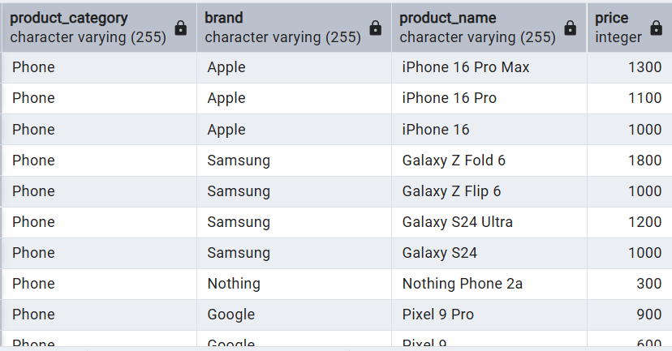

Write query to display the most expensive product under each category (corresponding to each record)
select *,
FIRST_VALUE(product_name) over(partition by product_category order by price desc)
from product;
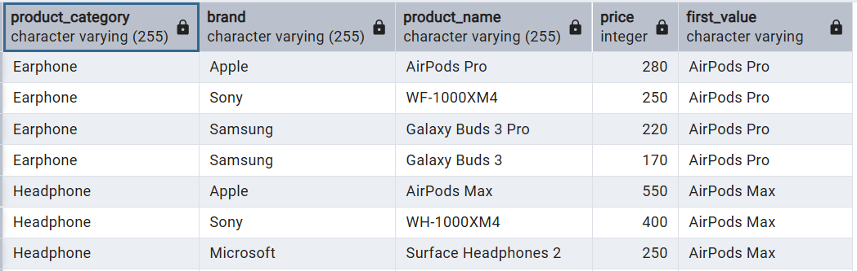

Last value:
LAST_VALUE () is a window function in MySQL that returns the last value from an ordered set of rows within a window (partition).

Write query to display the most & least expensive product under each category (corresponding to each record)
select *,
FIRST_VALUE(product_name) over(partition by product_category order by price desc) as most_exp,
LAST_VALUE(product_name) over(partition by product_category order by price desc) as least_exp
from product;
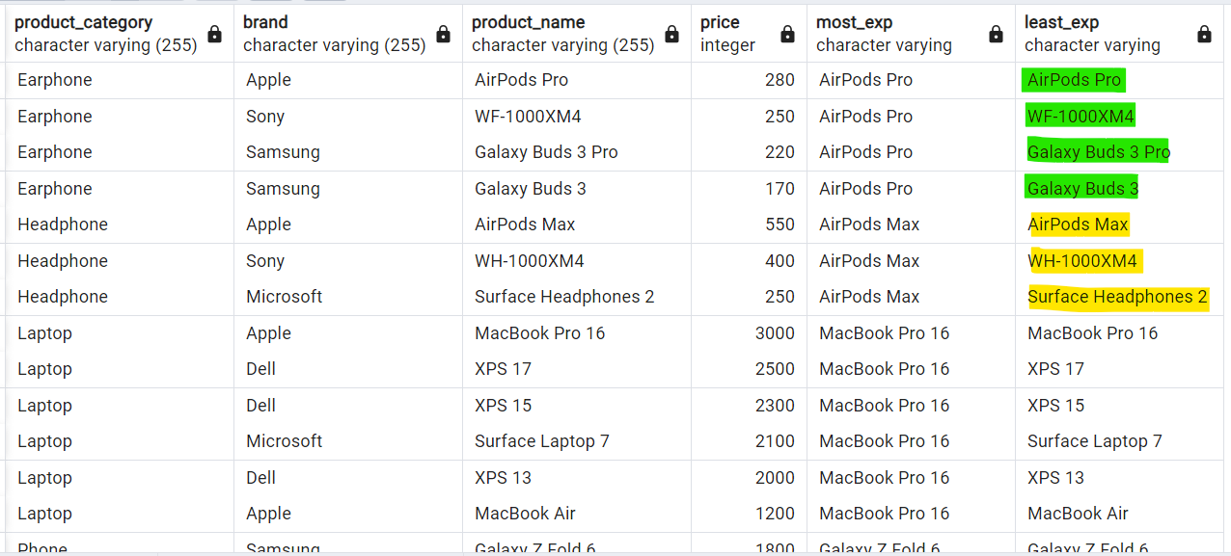

Note : We are not getting least expensive product name. Reason for this is .
Hierarchy of how SQL gets access to your data from query is:
Result set Window/Partition Frame
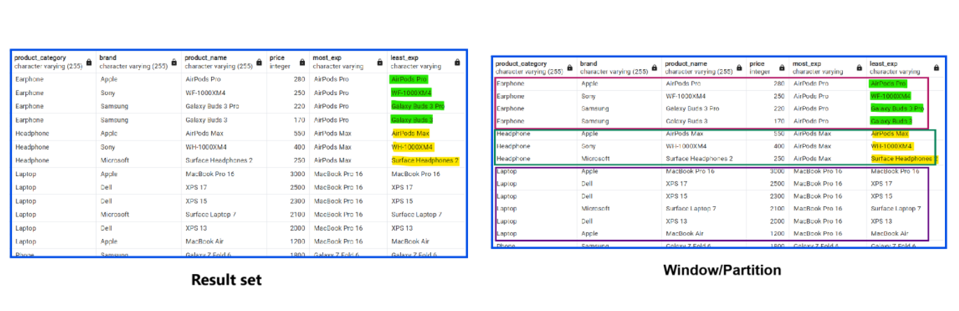

Frame cluse:
A FRAME CLAUSE in MySQL decides which rows inside the window should be considered when a window function is calculated.
Default, Frame clause “range between unbounded preceding and current row” This means
- When 1st iteration: frame having only 1 row that is AirPods Pro is unbounded preceding and current row so it shown that one only.
- In 2nd iteration: Frame will have AirPods Pro and WF-1000XM4 as unbounded preceding and current respectively, so last value is WF-1000XM4.
- Like at last iteration: Galaxy Buds 3 so shown that one. We can change that to total partition like this “range between unbounded preceding and unbounded following”
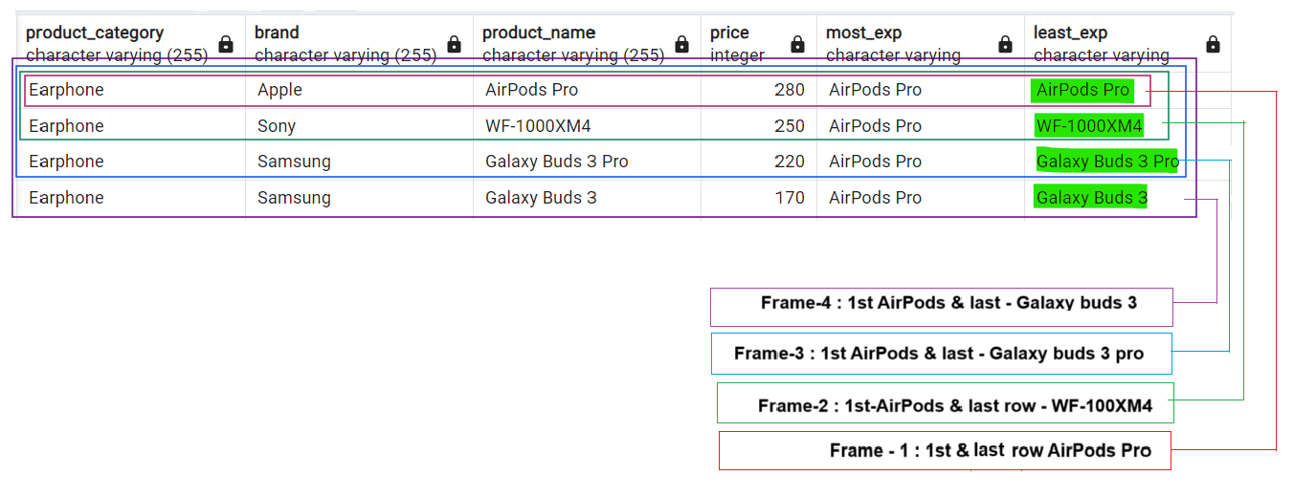

This we can fix by using frame clause.
select *,
FIRST_VALUE(product_name)
over(partition by product_category order by price desc) as most_exp,
LAST_VALUE(product_name)
over(partition by product_category order by price desc) as least_exp,
LAST_VALUE(product_name)
over(partition by product_category order by price desc
range between unbounded preceding and current row) as least_exp_current,
LAST_VALUE(product_name)
over(partition by product_category order by price desc
range between unbounded preceding and unbounded following) as least_exp_following
from product;
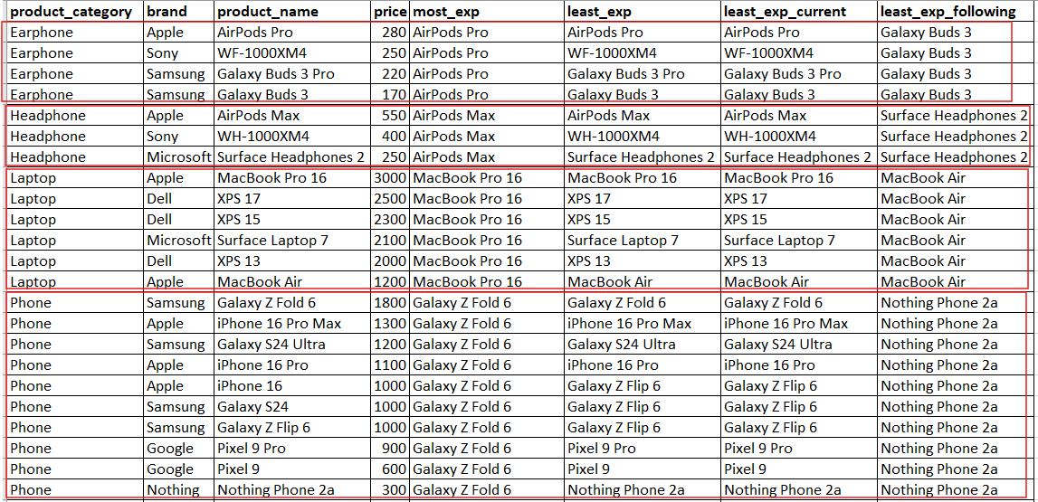

We can also do some change to frame clause like below.
Range Vs Rows with current row bounding:
When we have duplicated records in frame it behaves different. Lets get phone category and see how it dealing range and row with duplicate data.
With Range:
select *,
FIRST_VALUE(product_name) over(partition by product_category order by price desc) most_exp,
LAST_VALUE(product_name) over(partition by product_category order by price desc
range between unbounded preceding and current row) least_exp
from product
where product_category='Phone';
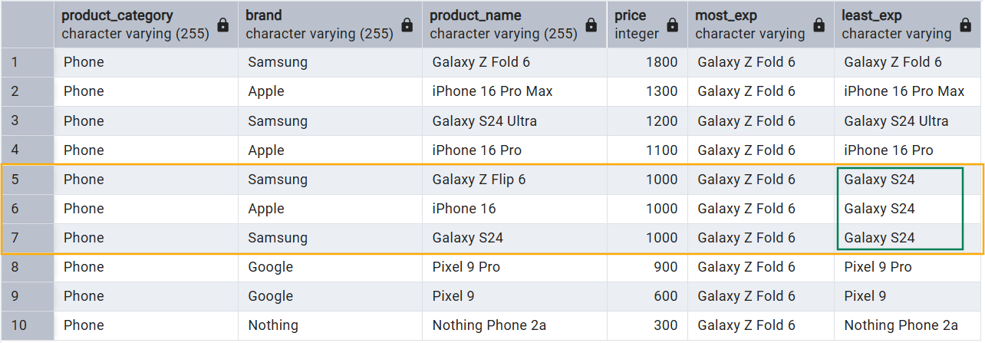

With Rows:
select *,
FIRST_VALUE(product_name) over(partition by product_category order by price desc) most_exp,
LAST_VALUE(product_name) over(partition by product_category order by price desc
rows between unbounded preceding and current row) least_exp
from product
where product_category='Phone';
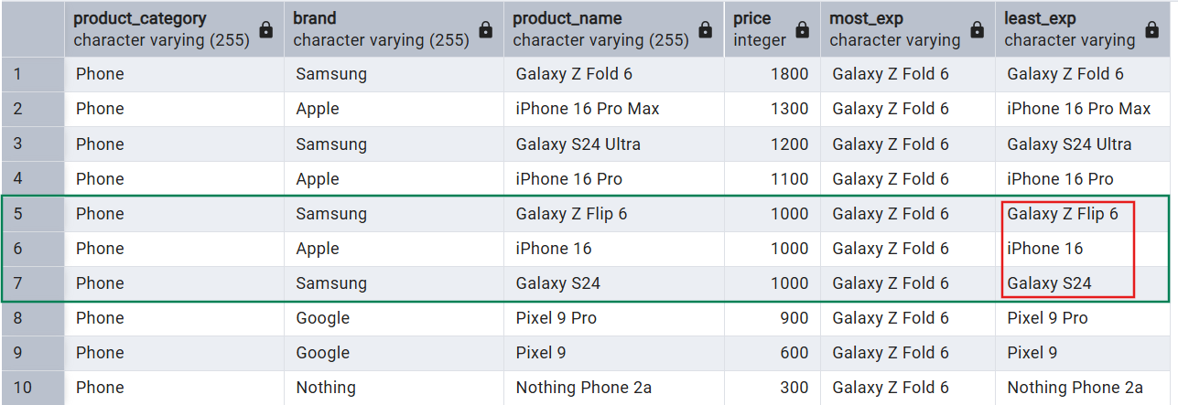

We can see that when we used range, we are getting same least product when price is same but when used rows getting that product itself.
When we are mentioning rows, frame is just taking that rows as preceding to that current row where as range means it took total frame include that duplicated so in range it showing last value.

Note:
- Other frame is like, range between 2 preceding and 2 following this will take 5 records as frame.
- Frame clause is very useful when we are using functions like last value, nth value and aggregate functions.

Alternative way to write window functions:
In our above query, we used same over clause again and again. But we can use window clause after from & where and it should be before order by clause.
select *,
first_value(product_name) over w,
last_value(product_name) over w
from product
where product_category in ('Headphone','Laptop','Smartwatch','Earphone')
window w as (partition by product_category order by price desc
range between unbounded preceding and unbounded following);
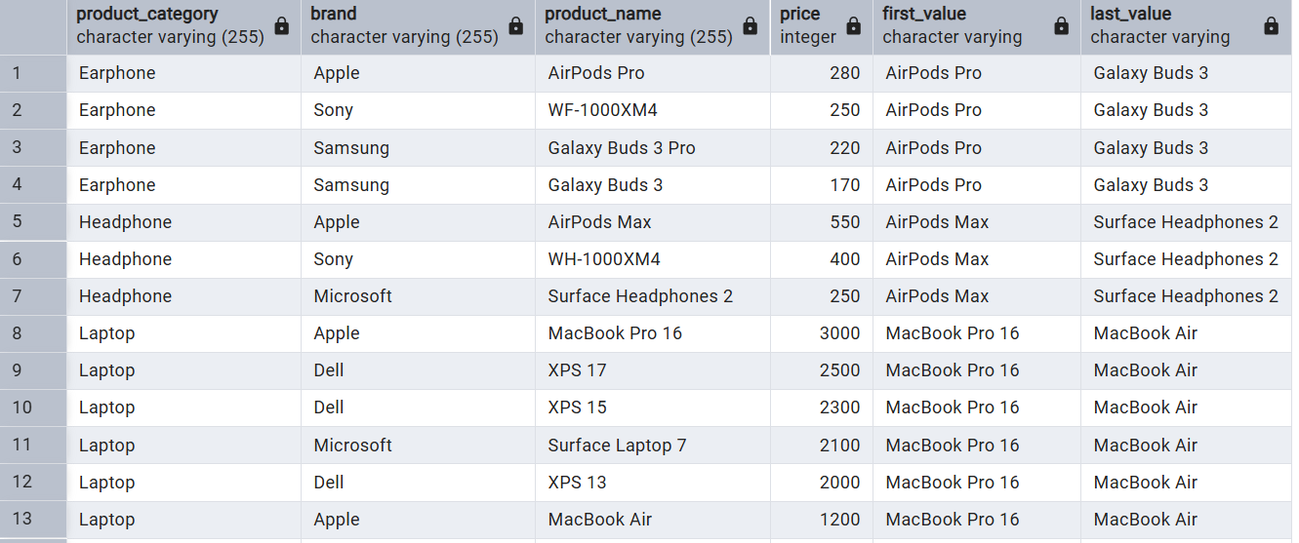

Nth Value:
NTH_VALUE() is a window function used to return the nth value from an ordered set of rows (a window frame).
2nd most expansive product from each category.
select *,
first_value(product_name) over w as Most_exp,
nth_value(product_name,2) over w as Second_most_exp,
last_value(product_name) over w as Least_exp
from product
where product_category in ('Headphone','Laptop','Smartwatch','Earphone')
window w as (partition by product_category order by price desc
range between unbounded preceding and unbounded following);
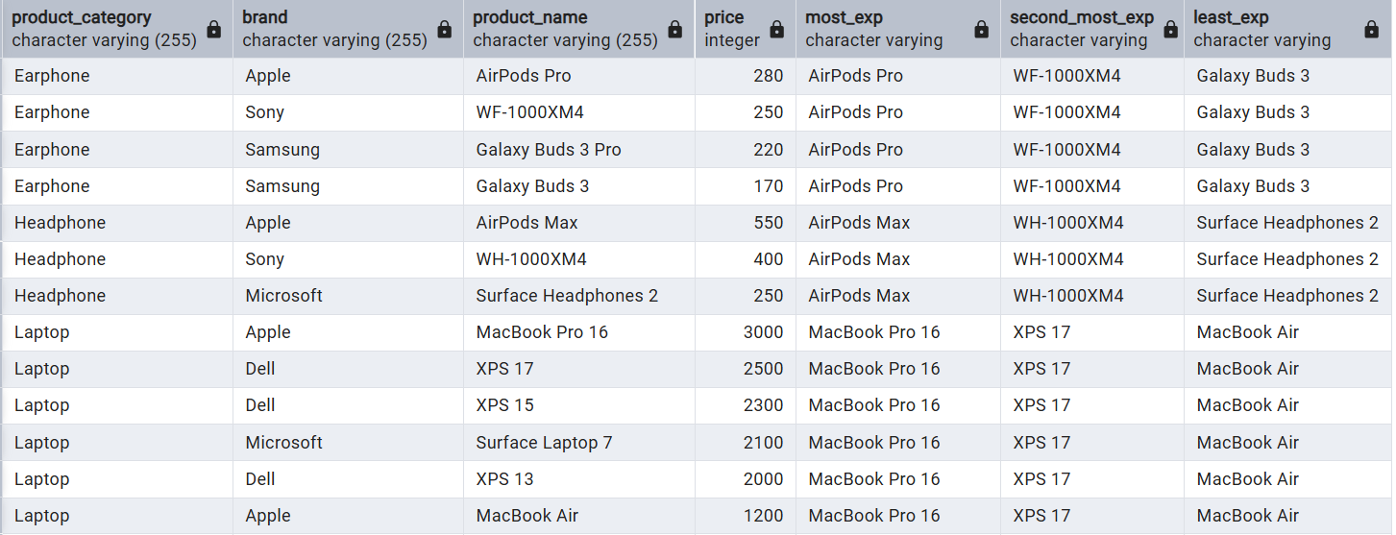

Note: If I pass 3 then I will get 3rd expansive product from data. If that nth value not found then it will return null.

NTILE:
NTILE(n) is a window function that divides the ordered rows into n equal-sized groups (buckets) and assigns a bucket number to each row.
OR
NTILE(n) distributes the rows in an ordered partition into n buckets, numbered 1 to n, as evenly as possible.

Write a query to segregate all the expensive phones, mid range phones and the cheaper phones.
select *,
ntile(3) over(order by price desc) as bucekts
from product
where product_category='Phone';

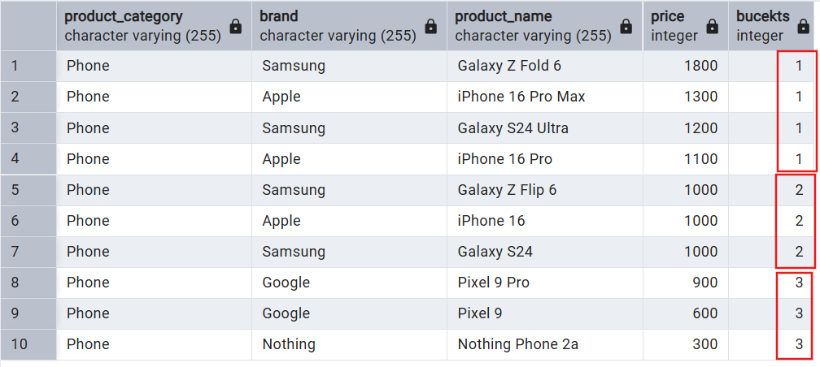

It, just simple dividing into 3 buckets. Like we have 10 records so first it given 3 each bucket then added extra to 1st bucket.

We can use Case statement on this to bucket to category products.
select tbl.product_name,
CASE
WHEN tbl.bucekts=1 THEN 'expensive'
WHEN tbl.bucekts=2 THEN 'Mid Level'
WHEN tbl.bucekts=3 THEN 'Cheaper'
END as "Price_Category"
from
(select *,
ntile(3) over(order by price desc) as bucekts
from product
where product_category='Phone') tbl;

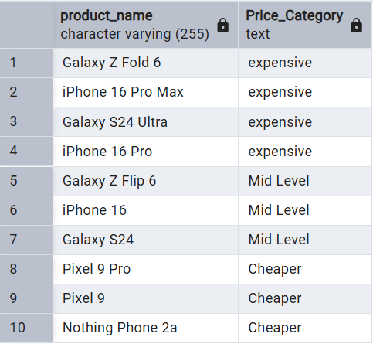

CUME_DIST:
CUME_DIST() is a window function that returns the cumulative distribution of a value within an ordered group.
Formula:
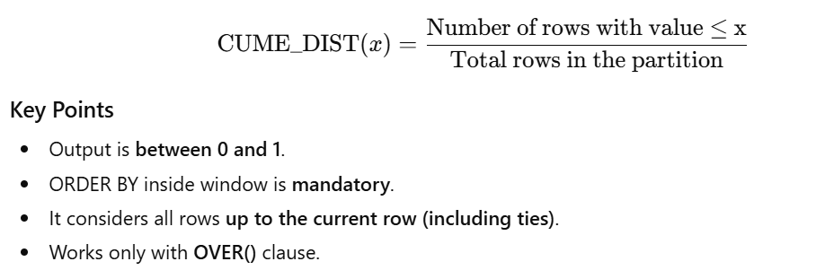
It simply takes current row number and divide with total number of rows in given partition and based order by column.
Query to fetch all products which are constituting the first 30% of the data in products table based on price.
select *,
cume_dist() over(order by price desc) as cumuliative_dist
from product;
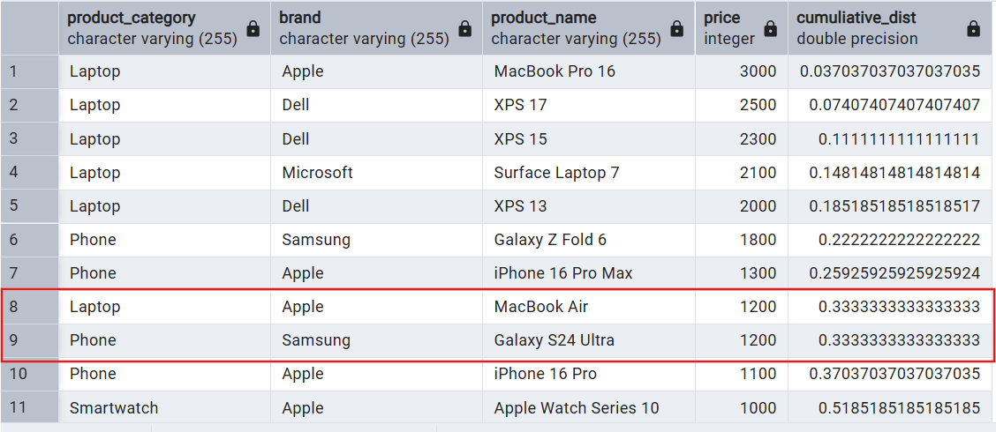

How it is calculating:
- Row number for 1st row is 1.
- Total number of rows are 27.
- 1/27 = 0.037037037037037
When any duplicates:
- For 8th and 9th rows it take 9 as row number as those are duplicated.
- Total number of rows 27.
- 9/27 = 0.3333333333333333
Like this it will calculate for all records. So values always lies between 0 to 1. Last records is always 1.
Let’s convert that into percentage.
select *,
cume_dist() over(order by price desc) as cumuliative_dist,
round(cume_dist() over(order by price desc)::numeric*100,2) as c_d_per
from product;
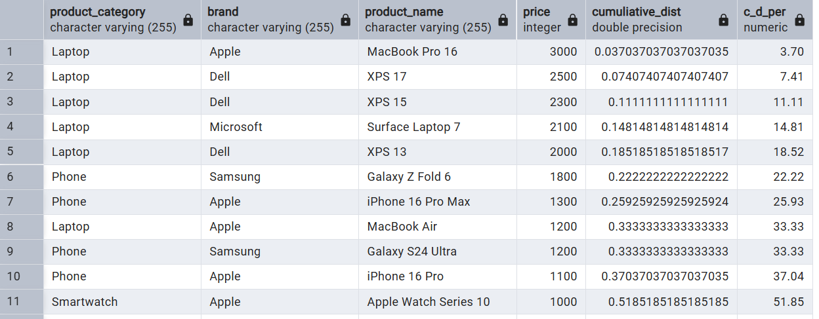

Now get data only where cume dist. is less then 30. So we get data which contributed to 30% of total data. (From high to low).
select product_name, c_d_per||'%' as Percentage
from
(select *,
cume_dist() over(order by price desc) as cumuliative_dist,
round(cume_dist() over(order by price desc)::numeric*100,2) as c_d_per
from product) tbl
where tbl.c_d_per <=30;
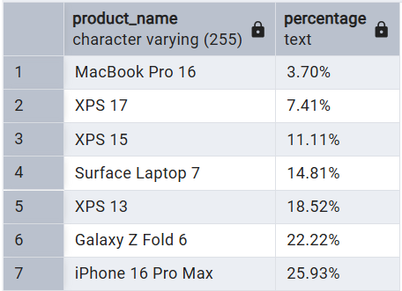

PERCENT_RANK:
PERCENT_RANK() is a window function that returns the relative rank of a row within a partition.
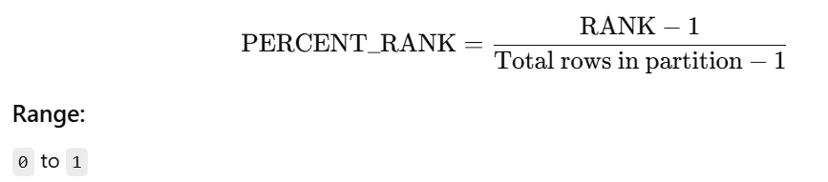
Query to identify how much percentage more expensive is "Galaxy Watch 5 Pro" watch when compared to all products.
select product_name,per_rank
from
(select *,
round(percent_rank() over(order by price)::numeric * 100,2) as per_rank
from product) tbl
where tbl.product_name ='Galaxy Watch 5 Pro';
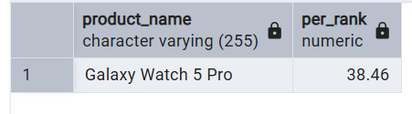

It saying that, Galaxy watch 5 pro is 38% expensive than other products.

